Abstract

A pulsed HF, AM transmitter, utilizing extremely high levels of over modulation has been designed and tested. Over modulation of an AM, RF signal, produces a pulse whose frequency is the same as the applied audio modulation frequency. In its final form, the transmitter had a un modulated carrier wave of 3.5 watts with a modulated output of 45 watts P.E.P. into a 50 ohm load. Rise and fall times of the pulse envelope were approximately 1 microsecond each. Pulse rate capabilities were in excess of 160 KHz.
Single frequency, square wave modulation produces no distortion of the audio when demodulated. Most, but not all, of the RF power in this transmitter is shifted to the side bands. The residual carrier eliminates the additional internal oscillator and mixer circuits necessary for side band receivers . The extreme levels of over modulation produce a demodulated wave of very high intensity which is not carrier wave power dependent. High harmonic levels, in conjunction with a variable audio input frequency, will produce a wide spectrum of impedances which can be used in therapeutic applications. The output signal is extremely difficult to jam and has potential military applications. The transmitter has potential for PAM digital radio transmission in a spread spectrum mode.

I. PULSED AM MODULATION

Two basic types of Pulsed AM modulation, were considered in the design phase of the transmitter. A short discussion of both types is necessary to understand the decision process prior to actual construction. All modulated signals mentioned in this paper should be considered to be square waves.
The RF signal output of either type of AM modulation circuit may appear similar on an oscilloscope, but there are significant differences in the demodulated signal. The two types which were examined are pulsed Continuous Wave ( CW) , and what is known as High Level, over modulated AM, using a modulation transformer. Each method has significant advantages , but each also has significant deficits.

_______________

^{ξ} email: jbare@rifetechnologies.com

A. Pulsed CW Transmission
The most common, and easiest to create method of Pulsed AM signal generation is that of gated or pulsed CW transmission. In this technique the carrier wave is turned on and off through use of a square wave to drive a gating circuit. The rate at which the carrier is turned on and off is equal to the applied square wave frequency. This produces a very rectangular pulse envelope, with a flat top and bottom. The pulse envelope width will vary directly with the duty cycle of the square wave. Pulse rates can easily extend into the MHz region due to the ability to generate very fast rise and fall times. Fast rise and fall times result in harmonic generation and the creation of sidebands. The primary transmitted power of the pulsed CW system is found within the carrier, and not the side bands. Only a percentage ( Generally less than 1/3 ) of the power is transferred to the side bands. Increases in the power of the carrier will increase power in the side bands, but the ratio between the carrier power, and that of the sidebands will stay at about 2:1.

B. High Level Over modulated AM
High level over modulated AM relies upon the injection of an audio signal between the driver and final output transistor. This is the method chosen for the transmitter discussed in this paper. The audio signal is passed through a modulation transformer and then combined with the RF carrier to produce the output envelope. In over modulation, the ratio of audio signal to that of the carrier is very high. This results in a rectangular pulse envelope similar to that found in Gated CW. Unlike Gated CW, the duty cycle is essentially fixed at approximately 50%. Rise and Fall (R/F) times under 1µs, and 100 KHz + pulse rates are possible using this method of modulation. But are not equal to the capabilities of Gated CW .
The majority of the RF power in over modulated AM transmission will be found in the side bands. So much power, that the device can be called a diminished carrier dual sideband transmitter. This is similar to some types of commercial FM stereo transmitters. The signal from this transmitter can in fact be received and demodulated on an FM radio . Square wave modulation produces some unique effects in an over modulated AM transmitter. A square wave is composed of an infinite number of the odd sine wave harmonics of the fundamental . In AM over modulation, the harmonics of the square wave become modulated and form side bands. When combined with the harmonics generated
by the pulse envelope, a very rich and wide band width of frequencies is produced. All frequencies are inter related and produced simultaneously (in the same time domain). When the signal is demodulated it is extremely intense. Many times louder in fact than that of a comparable pulsed CW transmitter of the same overall power level. Over modulation generally will result in severe distortion of the demodulated modulated wave due to clipping. Significantly, demodulation of an over modulated square wave will reproduce the square wave envelope without distortion.

II. TRANSMITTER DESIGN

The transmitter was designed to be utilized as an ISM (Industrial Scientific Medical ) band device operating at 27.12 MHz. The circuit consists of a Colpitts oscillator with sufficient output to excite the driver transistor for the final output transistor. A modulation transformer is utilized for audio band pass considerations. The usage of a transistorized high current amplifier circuit instead of the modulation transformer was explored and discarded. The circuit was found to have very limited band pass capabilities and would shut down at about 7 Khz.

A. Components
Primary components chosen for the circuit consisted of a Toshiba 7222A audio amplifier chip which is rated 5.8 watts audio power output with an 18 volt power supply . This chip was found to be capable of band passing almost 200 KHz when driven with 1 volt P-P positive offset square wave. R/F times were about 1µs. The RF power section consists of a 2SC 1957 transistor producing about 1 watt output. This was used to drive a 2SC1969 final output transistor rated at 22 watts PEP. A TF 129 modulation transformer was used which has a rated output of approximately 24 volts @ 1 amp.

27.12
Osc.
1957
1969
TF129
Mod
Xfmr
Audio
Amp
Figure 1. Basic Component layout of transmitter.

B. Development Problems

Initial design showed problems with feed back oscillation into the Colpitts circuit. This was solved by moving the oscillator circuit to one end of the pc board and placing the RF output section on the opposite end of the pc board. Maximum RF power was derived by careful tuning of the tank circuits. This was accomplished by minimizing resistor and inductor values. The resistor values tend to set the collector current/voltages as well as affect the resonance of the circuit. A few of the inductors were nothing more than one to two turns of wire that needed to be separated. When measured, these inductors essentially had no value, yet their replacement with straight wires would drop output power levels. Power levels were maximized at about 45 watts PEP with 10KHz input audio frequency. Power levels demonstrated a linear relationship with the audio modulation frequency, up to 10 KHZ. Power would rise from about 4 watts PEP at 10 Hz , and continue to rise to 10 KHz. Beyond 10 KHz, output power was maximized with a slight drop off beginning about 100 Khz, and then continuing to diminish to a cut off near 175 KHz.

C. Audio Circuit and Pulse Envelope Shape
The ability of 7222A audio amp to maintain a high pulse rate and envelope shape was found to be dependent upon the addition of a large capacitance to the power input of the chip. 3300 mfd was necessary to maintain the pulse rate and envelope shape. Some sag of the top and bottom of the pulse envelope could be found above 120 KHz. Frequencies in the 500 Hz to 30 KHz region produce extremely well shaped rectangular pulse envelopes.

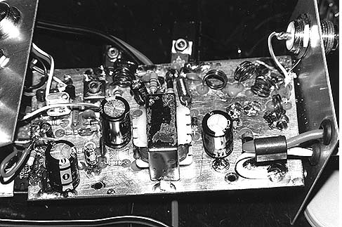

Figure 2. PC Board and parts placement of transmitter.

The addition of large capacitances to the RF tank circuits was also necessary to increase pulse rates and enhance envelope shape. The problem that initially arose is that such large capacitances in conjunction with the inductors and resistors of the tank circuit affect the capacitor charge/discharge times. This affected rise and fall times of the pulse envelopes and distorted envelope shape. As inductance values and resistance values were removed from the tank circuits, not only did output RF
power rise, but the pulse rate increased, R/F times diminished, and pulse envelope shape was enhanced. Pulse output capabilities of the transmitter showed that limitations are being imposed by the audio amplifier . R/F times of the pulse envelope were right at 1µs, with pulse rates of up to 160 KHz with acceptable power and envelope shape.

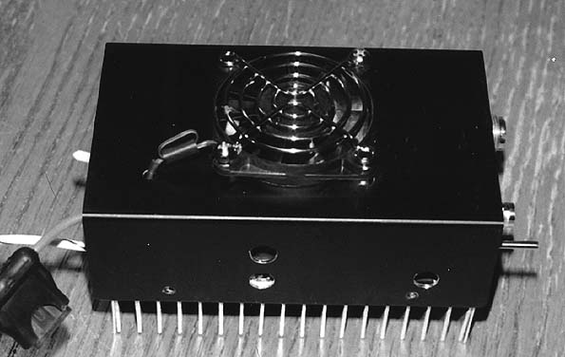

Figure 3. Amplifier with cooling fan. Finished version was fitted with a fan on/off switch, BNC jack for square wave input, transmit switch , and a separate microphone jack for use with a computer based frequency generator .

III. ACCESSORY COMPONENT DIFFICULTIES

The wide bandwidth of frequencies, and high pulse rates, generated by the transmitter created some unique problems with accessory components.

A. Coaxial Cables
Coax cable lengths became a critical part of maximizing power output, and minimizing Standing Wave Ratios ( SWR) in the transmitter. When the transmitter is connected to a linear amplifier, the coax cable was found to be optimal at lengths of 18 inches and 18 feet. Any less than 18 inches would drop power and increase SWR’s. The length of coax from the linear amplifier to the antenna tuner produced best readings only at 18 feet. Lengths from 18 inches to 27 feet were tried. 18 feet is ½ wave length of 27.12 MHz. Conduction velocity corrections in cable length were tried, and found not to be applicable due to the wide band width of the output.

B. Linear Amplifier
Many linear amplifiers have built in harmonic suppression. This would defeat the purpose of the transmitter. Such a transmitter was not used. At high pulse rates, it was found that parts of the bias circuits in the amplifier would tend to overheat and fail. This could within just a few short minutes of operation at pulse rates over 50 KHz. Identification of the overheating parts was simplified by operating the system at around 25 KHZ for 30 seconds and then checking components for excessive heat. Resistors were replaced with higher wattage ratings, and capacitors were replaced with slightly higher voltage ratings, but significantly higher capacitances. Anywhere from 50 to 200 times the original value was needed to stabilize an overheating capacitor.

C. Power Supplies
The high pulse rates of the transmitter and linear amplifer places a great burden on the power supply. Extra external capacitance needs to be added to overcome the demands for large amounts of current. An additional 40,000 to 60,000 µf of capacitance should be added across the output terminals of the power supply. This extra capacitance will assure a steady pulse envelope and power level regardless of the pulse rate.

IV. APPLICATIONS

Impedance is an electrical value that is frequency dependent. When impedances match, energy will transfer at a maximum rate from a source to a sink. The high harmonic output and variable modulation frequency capability of the transmitter make it ideal for use as a therapeutic device. When coupled to a plasma tube antenna, which acts as an electronic mixer, harmonic generation becomes quite prodigious. Odd and even harmonics are generated , as well as heterodyne products.

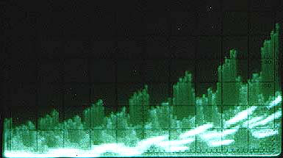

Figure 4. Spectral Scan of transmitter output to a plasma tube. There are odd and even harmonics as well as heterodyne harmonics being expressed

Impedance matching allows for the transfer of energy . in this case into the human body. The frequency selective capability of the transmitter means that certain tissues and cells may be isolated and targeted based upon their respective impedances. The transmitted wave, once it is absorbed, can be demodulated. The majority of the energy of the EM wave being in the sidebands, demodulation can create the presence of very intense audio waves . These audio wave can act locally at the point of energy absorbtion and demodulation.

A. Harmonics and Ultra Sound
A square wave produces odd harmonics of it’s fundamental. Each harmonic would have only ½ the power level of the harmonic preceding it. When a square wave is applied at 2000 Hz the harmonics generated would be 2k, 6k, 10k, 14k, 18k, 22k and so on As can be seen, the 6th , and all further odd harmonic become ultrasonic. Audio frequencies from 20Khz to 100 Khz, are known as low frequency ultrasound. Low frequency ultrasound is being used as a physical therapy modality which produces deep tissue penetration at very low power levels. For example, the DuoSon is a low frequency ultrasound unit, which operates in the 40 KHz region. It uses 30 times less power than a comparable MHz ultrasound therapeutic device, to produce similar physiologic effects.
Ultra sound (US) intensity levels are generally recorded as watts/square cm. at the piezo electric head. This can translate to a field strength which will vary with the square of the distance from the US emitter. If the pulsed EM wave can be demodulated, it is possible that it will produce US acoustic waves at the point of demodulation. At very minute (micron) distances, even a small signal could have very dramatic effects.

B. Military Applications
The spread spectrum of the transmitter is very difficult to jam. This makes the transmitter ideal for military applications and usage in poor weather conditions where propagation is difficult. The overall power of the transmitter is spread across the harmonic spectrum . Any one frequency may have only a small amount of power in it, yet all harmonics are produced within the same time domain . If a receiver can be constructed that will do a Fourier addition to the signals, a very powerful individual signal can be received out of the many weak harmonic signals.

C. Pulsed Amplitude Modulation (PAM )
PAM transmitters are used for the digital transmission of data. These transmitters are primarily Pulsed CW types and are not capable of easily changing the amplitude of the pulse envelope. This transmitter can change the pulse envelope amplitude through either changes in the applied audio frequency, or changes in the audio input level.

V. Summary

This transmitter has several different commercial applications. It’s primary focus is that of a driver for a pulsed RF, non thermal therapeutic device. It produces a wave form that is theoretically capable of creating dramatic physiologic effects.
The problem of course, is finding frequencies that will match impedance of specific desired spot within the body. Once impedances match, the absorbed EM pulse must demodulate. The demodulated wave must convert to an acoustic wave, where finally, ultrasonic emissions can be physiologically active. From a therapeutic standpoint, one can make certain assumptions. In the case of a disseminated problem, a general impedance match to the body as a whole could be adequate. In the case of a localized problem, only an exact impedance match will do.
The author will leave the reader with a simple statement: The transmitter when coupled to a variable frequency square wave generator, a linear amplifier, and a plasma tube has produced some very intriguing empirically observed physiologic responses. It is not the nature of this paper to discuss these, other than to say they do occur, and much more research is needed.

