HALF-WAVE RESONANCE OF BACTERIA DNA IRRADIATED FROM 4 TO 8 GHZ

Gérard Dubost^{1*}, André Bellossi²
^{1*}Emeritus Professor, I.E.T.R. University of Rennes1, France.
²Professor Faculty of Medicine, University of Rennes1, France

- INTRODUCTION
A new theoretical concept is presented to explain the disruptive effects on some bacteria irradiated by an electromagnetic field. We suppose a half-wave resonance of their DNA. A proof-of-concept experiment by two electronic devices associated with various gas plasma antennas is given.

- METHODS
It has been shown that AC conductivity of DNA in the millimetre range is largely ascribed to relaxational losses of the water dipoles in surrounding hydratation layers. The total number of water molecules per nucleotide has to be correlated with the relative humidity. For instance the adsorption of water molecules per nucleotide is equal to 13 for a rate of humidity (R.H) equal to 84%, and 4 for R.H of 60%. For an R.H of 0% there are 3 water molecules per nucleotide which cannot be removed from the helix. The DNA conductivity of calf thymus at 100 GHz is equal to 25 S/m for a R.H of 84%. For a R.H equal to 0% the DNA conductivity is only of 1 S/m [1].
We suppose the DNA half-wave resonance at a frequency F such as:
F=c/2L [ε_{r}(F)]^{1/2} =c/[ε_{r}(F)]^{1/2}2. N_{PB} .l₀ (1)
N_{PB} is the base-pairs number, l₀ the distance between two consecutive bases counted along the helix strand, c is the light speed in the vacuum, ε_{r} is the relative permittivity of the water at the frequency F.
The table 1 shows the various parameters for some bacteria.

Bacteria | N _{Pb} | F  (GHz)  (1) | L (mm)  ou  N_{PB}. l₀ | A  (dB)
Staphylococcus aureus MRSA252  March 2001 | 2902619 | 7.46 | 2.37 | 2.20
Actinomyces HOMD , Feb 2007 | 3042856 | 7.11 | 2.48 | 1.92
Enterococcus faecalis V523 March 2003 | 3218031 | 6.73 | 2.63 | 1.90
Mycobacterium leprae | 3268203 | 6.62 | 2.67 | 1.86
Proteus mirabilis H14320 | 4063606 | 5.33 | 3 .32 | 1.59
Mycobacterium tuberculosis  CDC1551 , May 2001 | 4420576 | 4.90 | 3.61 | 1.44
Salmonella typhi STRCT18  November 2001 | 4809037 | 4.50 | 3.93 | 1.37
Escherichia coli 0157H7 | 5528445 | 3.92 | 4 .51 | 1.25

Table 1: Parameters for some bacteria

A is the wave absorption along the DNA strand of length L symmetrically excited with A=A_{L}.L/2 , where A_{L} is the wave absorption coefficient in the water given below in terms of the frequency F, also with the conductivity σ and the relative permittivity ε_{r} (below table 2).

F(GHz) | BULK water | SEA water | FRESH water
1 | σ=0.2(S/m),ε_{r}=80  A_{L}=0.04 (dB/mm) | σ=6(S/m),ε_{r}=70  A_{L}=1(dB/mm) | σ=0.15(S/m),ε_{r}=80  A_{L}=0.03 (dB/mm)
5 | σ=5.2(S/m),ε_{r}=75  A_{L}=1(dB/mm) | σ=10(S/m),ε_{r}=60  A_{L}=2(dB/mm) | σ=4.5(S/m),ε_{r}=75  A_{L}=0.85(dB/mm)
10 | σ=17.3(S/m),ε_{r}=64  A_{L}=3.5(dB/mm) | σ=17(S/m),ε_{r}=50  A_{L}=3.8(dB/mm) | σ=15(S/m),ε_{r}=70  A_{L}=2.9(dB/mm)

To explain the bacteria destruction via their DNA, we refer to two confined gas plasma antennas lighted with a square wave modulated RF electronic discharge .Plasma oscillation frequencies are generated very near of the ionic plasma frequency equal to:
f_{i}=(e/2π)( Δ n_{f} /ε₀m_{i})^{1/2} (2) ,m_{i} is the ion mass, Δ n_{f} the ion density related to the non linear behaviour of the plasma which depends of the modulation frequency, e the elementary electric charge and ε₀ the vacuum permittivity.

When we can neglect the Landau weakening, that is when T_{e}>>T_{i} , T_{e} and T_{i} being the electron and ion temperatures ,the plasma ionic oscillation frequencies F=Ώ/2π are given by:
Ώ²=Ώ_{i}² +3KT_{i}k²/m_{i} , with k= Ώ(m_{i}/KT_{e})^{1/2} ; K(J/degree) is the Boltzmann constant. Then we have: Ώ²(1-3T_{i}/T_{e} )= Ώ_{i}² and F#f_{i} .
C_{S}= Ώ/k=2πF/k= ( KT_{e}/ m_{i} )^{1/2} is the low speed pseudo sonorous waves.

- RESULTS. RIFE-BARE DEVICE
Recalled in [2] the confined plasma antenna is filled with argon gas at a pressure of 50 mm. The ion density/m³, equal to: Δ n_{f} =10²⁸/(f_{m})² (3) ,where f_{m} is the pulsed modulation frequency (in Hz) of the carrier frequency equal to 27 MHz, is given Table 3.

f_{m}(Hz) | 200 | 300 | 500 | 800 | 1000 | 10000
Δ n_{f} /m³  (3) | 2.10²³ | 10²³ | 4.10²² | 1.5. 10²² | 10²² | 10²⁰
Table 3

With (2), (3) and m_{i}=6.63.10⁻²⁶ Kg, we deduced: f_{i}.f_{m}=3.3.10¹² (4), fi in GHz and f_{m} in Hz.
When f_{m} is increasing from 413 to 825 Hz, f_{i} is decreasing from 8 to 4 GHz. The correlation between F on Table1 and f_{i} is right, and shows that the RIFE-BARE device is able to destroy the bacteria at the “mortal frequency” f_{m}, the destruction being due to the F#f_{i} frequency.
With T_{e}=3.10⁴ Kelvin, we find C_{S}=2500 m/s.
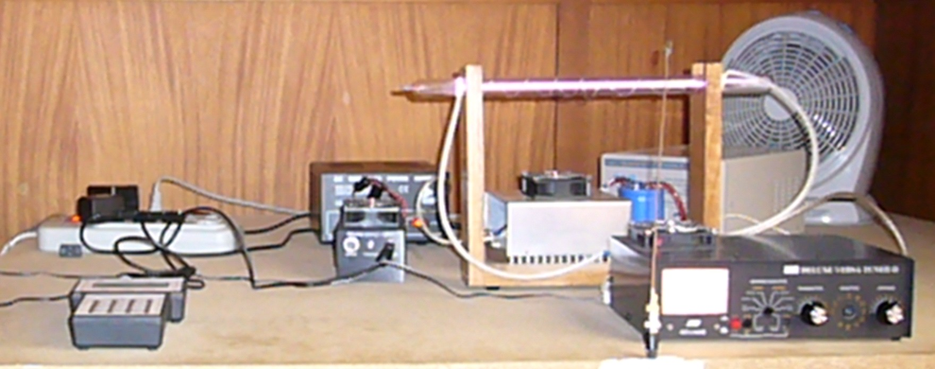
Wave amplifier
Transmitter
Confined plasma

Square wave generator
Loop
Antenna tuner

- RESULTS RIFE DEVICE
For the Rife device (1939) recalled in [3], a spherical tube called phanotron filled with helium gas at a pressure of 12 mm, is excited with a carrier of 4.6 MHz modulated by a pure sinusoidal frequency. The neutral helium atom density n₀ is given in terms of the pressure :n₀=P₀/KT₀ (4) With T₀=300K and an ionization degree of 1/100, the helium ion density is:
Δn=3.8.10²¹/m³.With m_{i}=6.64.10⁻²⁷ Kg, the maximum ionic plasma frequency was with (2): (f_{i})_{M} =6.5.10⁹ Hz. This value is a right amount in comparison with the half-wave bacteria resonance frequencies F (Table 1).With T_{e}=3.10⁴ Kelvin the speed C_{S} of the pseudo sonorous waves is equal to :7300m/s.
On the table 4 we present the “mortal frequencies” measured by Rife (1939), and the theoretical “mortal frequencies” deduced from (4) related to the Rife-Bare device with f_{i}#F.

Bacteria | Theoretical “mortal frequencies” f _{m} (Hz) | Measured “mortal frequencies” by Rife (Hz)
Staphylococcus aureus MRSA252 | 442 | 727
Actinomyces HOMD | 464 | 784
Enterococcus faecalis V523 | 490 | 757
Mycobacterium leprae | 498 | 783
Proteus mirabilis H14320 | 619 | 767
Microbacterium tuberculosis  CDC1551 | 673 | 803
Salmonella typhi STRCT18 | 733 | 712
Escherichia coli 0157H7 | 842 | 803
Table 4: Theoretical and measured “mortal frequencies”

From the high accuracy of the modulation frequency measured by Rife(Some Hz) we deduced from(4): df_{i}/f_{i}=-df_{m}/f_{m,} and then the high selectivity of the DNA bacteria at resonance.

- CONCLUSION
The DNA half-wave resonance hypothesis of bacteria irradiated by frequencies between 4 and 8 GHz has been justified by experiments. It was necessary to know the base-pair numbers of the DNA bacteria surrounding by several hydratation layers. The relative high conductivity of the DNA strand and its weak wave absorption can be largely ascribed to relaxation losses of the surrounding water dipoles. There is essentially no charge conduction along the DNA backbone itself. So the half wave resonance can be considered in spite of the helix DNA strand in the shape of a ball.

- REFERENCES
[1] M. Briman,N.P Armitage et all “Dipole relaxation losses in DNA” depart. of Physics and Astronomy,University of California, Los Angeles, CA 90095, 8 November 2005.
[2] G.Dubost, A.Bellossi « Rayonnement électromagnétique de solitons d’une antenne à plasma confiné » Colloque international sur la compatibilité électromagnétique, et les journées scientifiques du CNFRS/URSI 20-23 mai 2008, Paris 2008.
[3] Aubrey Scoon « Report of the British Rife Group » Rife Technology Conference. Las Vegas March 2002

